**Buyer Requests**

I would like to have a chart or diagram

- 5 best-selling products after people enter the festival (1st purchase)

- 5 best-selling products after the 1st one (2nd purchase)

- 5 combinations of 2 products that sold the most (visitors bought 1) beer and burger, 2) wine and pasta, 3), etc., etc.)

- Top-Up Planning XLS: Timeline per hour -> how many transactions (rows in the XLS) per hour per refill location

>> Sales questions:

- What is the first product they buy and what is the last product they buy before leaving (top 5 products of all visitors)

- What is the 2nd product they buy (top 5 products of all visitors)

- What is the combination of products that are sold the most (top 5 products of all visitors)

- What are the top 5 buyer personas

>> Top-Up questions

- When are the peak times at the top-up stations (for each top-up station: the number of transactions per hour over the whole day)

- How much money is top-upped during these hours over the whole day

**Graphs and Charts**

**5 best selling products after people enter the festival (1st purchase)**

**Item Name : Category: Department**

1. Service Flat : Facilities : Non-Food - 20.78%
2. Melt Beer : Tap Beer : Drinks - 10.80%
3. Sani Flat : Facilities : Non-Food - 3.14%
4. Holster Pil Dose : Beer : Drinks - 2.8%
5. Shuttle Flat : Facilities : Department - 2.71%

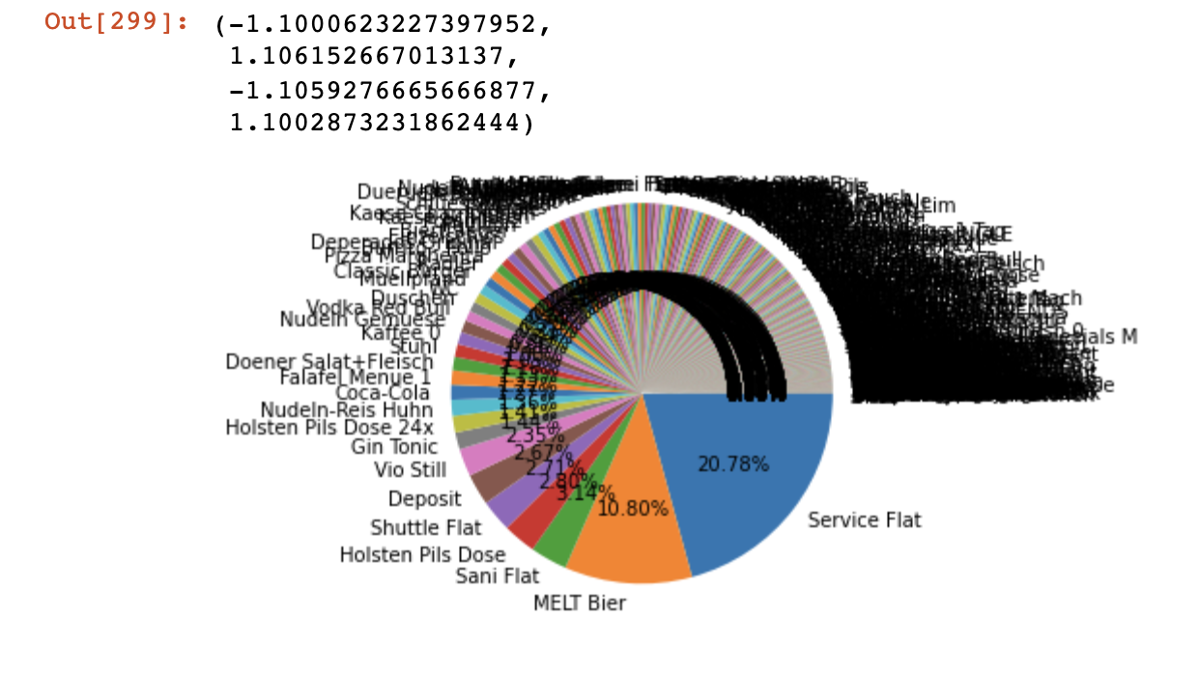

**5 best selling products after the 1st one (2nd purchase)**

**Item Name : Category: Department**

1. MELT Beer : Tap Beer : Drinks - 13.05%
2. Deposit : Deposit : Non-food - 10.15%
3. Service Flat : Facilities : Non-food - 4.55%
4. Vio Still : Soft Drink : Drink - 3.61%
5. Spend 5 Eur : Nos : Other - 2.26%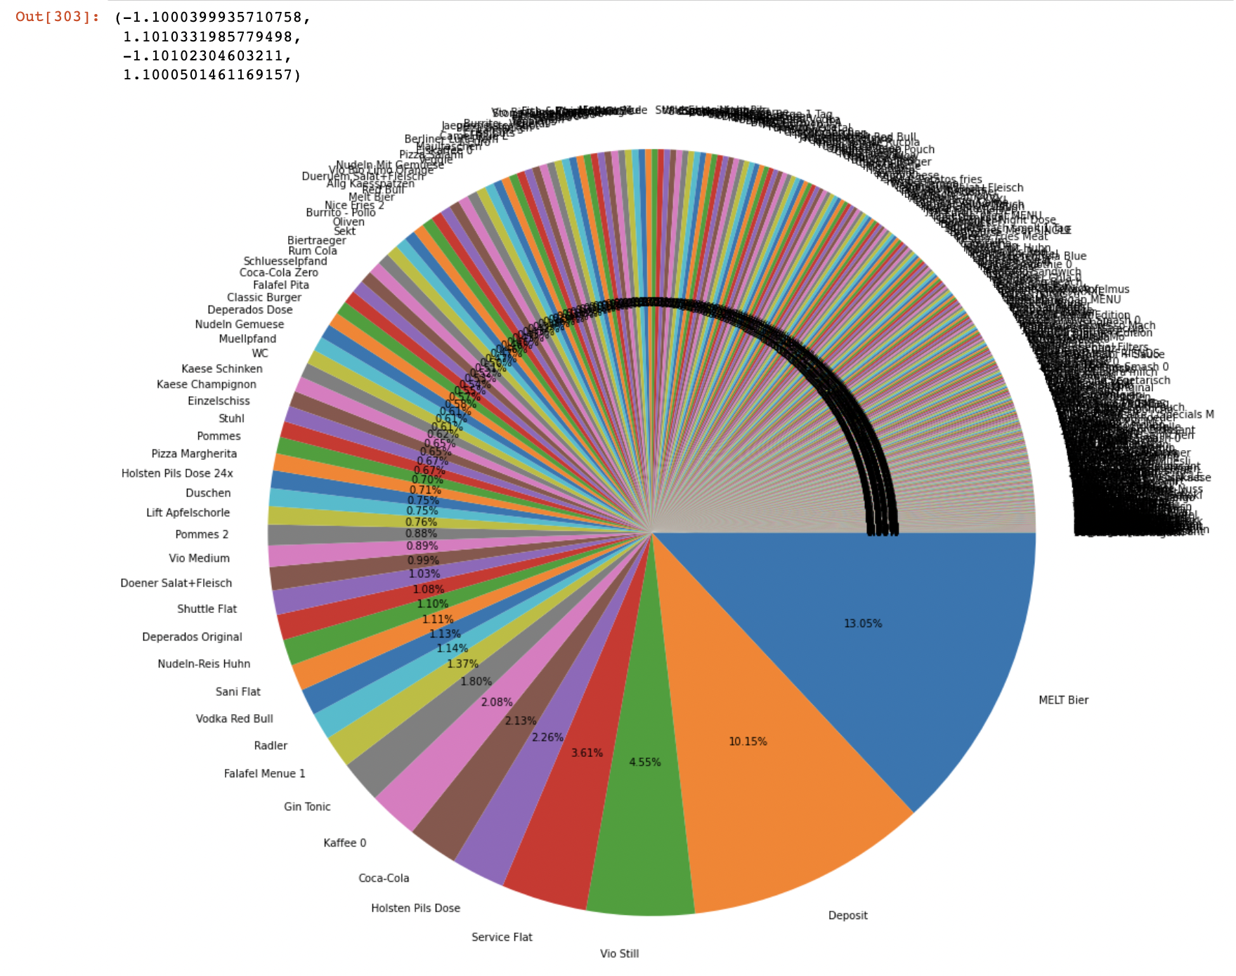

**combinations of 2 products that sold the most (visitors bought 1) beer and burger, 2) wine and pasta, 3), etc., etc.)**

**Item 1 : Item 2 : Correlation**

1. Tap Beer And Deposit : 0.570354
2. Beer and Deposit : 0.376699
3. Spirit and Deposit : 0.327995
4. Soft Drink and fast food : 0.315974
5. Soft Drink and Deposit : 0.299066

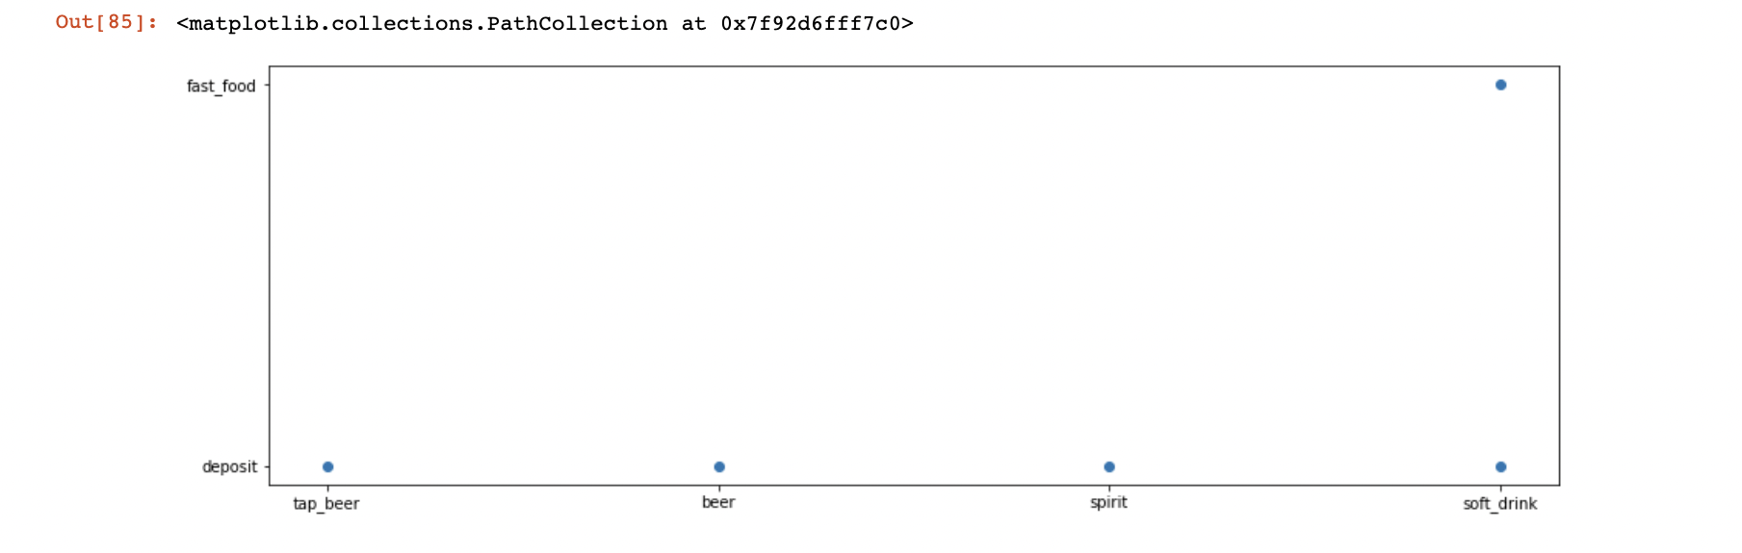

**Top-Up Planning XLS: Timeline per hour -> how many transactions (rows in the XLS) per hour per refill location**

**Hour: Transactions**

**10: 177**

**13: 142**

**11: 111**

**9: 109**

**12: 49**

**8: 44**

**7: 25**

**6: 13**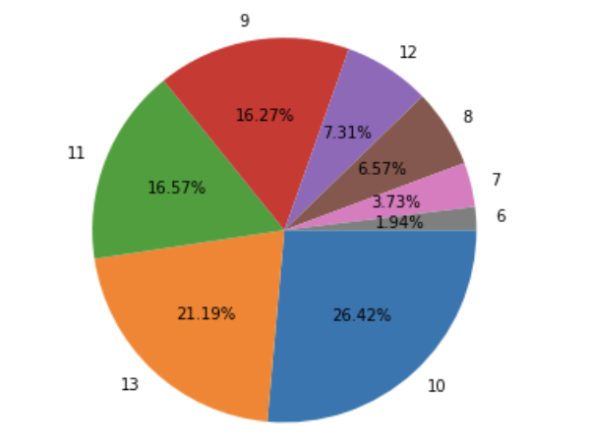

**Questions And Answers**

**What is the first product they buy and what is the last product they buy before leaving**

In the data, we can see most people tend to buy the Service flat as their first purchase with over 20% of all first purchases being the service flat

* Top 5

1. Service Flat
2. Melt Beer
3. Sani Flat : Facilities
4. Holster Pil Dose : Beer
5. Shuttle Flat : Facilities



On the other hand, we can see that their last purchase usually tends to be Deposits with 20.81% of last purchases being deposits. 2nd being Muellfand at 12.7%.

Top 5

1. Deposit
2. Muellpfand
3. BELT beer
4. Vio Still
5. Kaffee 0

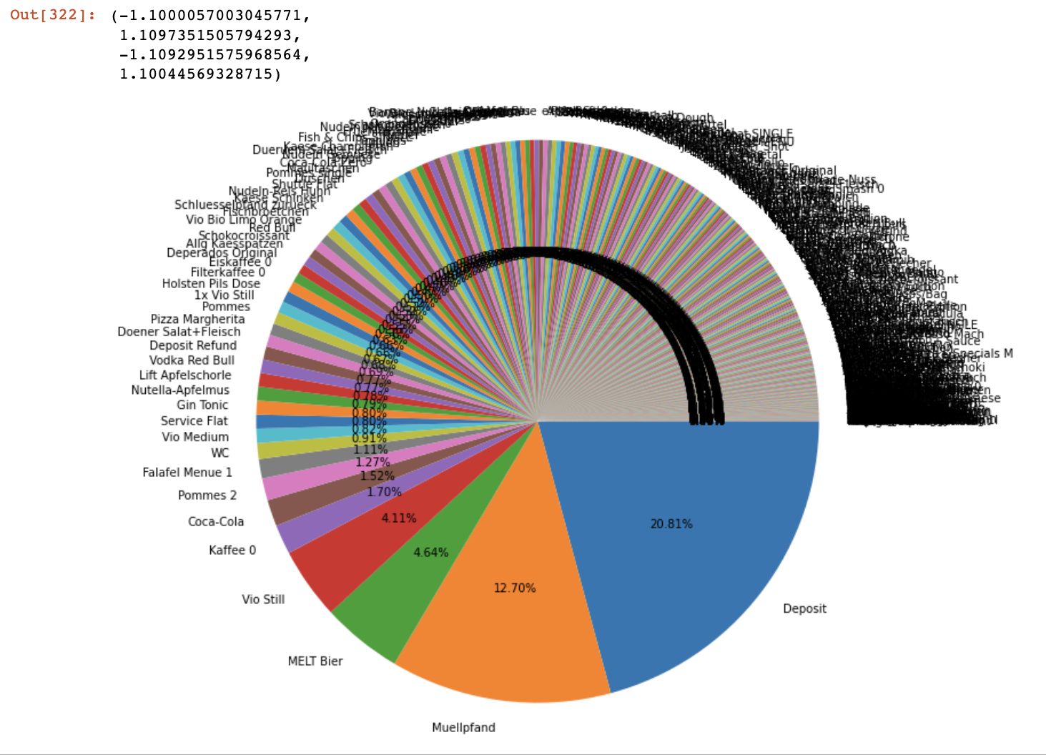

**What is the 2nd product they buy (top 5 products of all visitors)**

The most popular product they bought second was Melt beer which took up around 13% of the sales.

Top 5

1. MELT Beer - 13.05%
2. Deposit - 10.15%
3. Service Flat - 4.55%
4. Vio Still - 3.61%
5. Spend 5 Eur - 2.26%



**What is the combination of products that are sold the most (top 5 products of all visitors)**

**Item 1 : Item 2 : Correlation**

1. eer And Deposit : 0.570354
2. Beer and Deposit : 0.376699
3. Spirit and Deposit : 0.327995
4. Soft Drink and fast food : 0.315974
5. Soft Drink and Deposit : 0.299066

**What are the top 5 buyer personas**

1) It seem the highest type of thing people buy tend to be desposits as it holds the highest share for items and category chart, and also has a large chunk for the department with non_food. We an infer pretty easily that most poeple tend to ask for services for deposits in the festival

2) From The category and department charts, a lot of people tend to go for and order drinks as it takes of 41.49% of the departments chart and over 30% of the Category chart

3) For the first purchases, people tend to go for deposits with around 13% and then MELT beer with around 10%

4) For the second purchases, people usually buy MELT beers (13.05%) and then deposits(around 10%), so those are pretty good to stock up in the beginning.

5) The best non food are deposits, the best food people buy is fast food, and the drink people buy the most is tap beer

**When are the peak times at the top-up stations (for each top-up station: the number of transactions per hour over the whole day)**

Station 1.1: 211 total transactions with the peak time being hour 10

Station 1.2: 159 total transactions with the peak time being hour 10

Station 1.3: 136 total transactions with the peak time being hour 13

Station 2.4: 72 total transactions with the peak time being hour 10

Station 2.5: 62 total transactions with the peak time being hour 10

Station 2.6: 30 total transactions with the peak time being hour 11

**How much money is top-upped during these hours over the whole day**

Station 1.1: 53 Transactions and 572 Euros top-uped during hour 10

Station 1.2: 61 Transactions and 850.2 Euros Top-uped during hour 10

Station 1.3: 134 Transactions and 1995.8 Euros Top-uped during hour 13

Station 2.4: 26 Transactions and 496.7 Euros top-uped during hour 10

Station 2.5: 28 Transactions and 500.9 Euros top upped during hour 10

Station 2.6: 11 Transaction and 179.4 Euros Top upped during hour 11